**Natalia Logvinova**

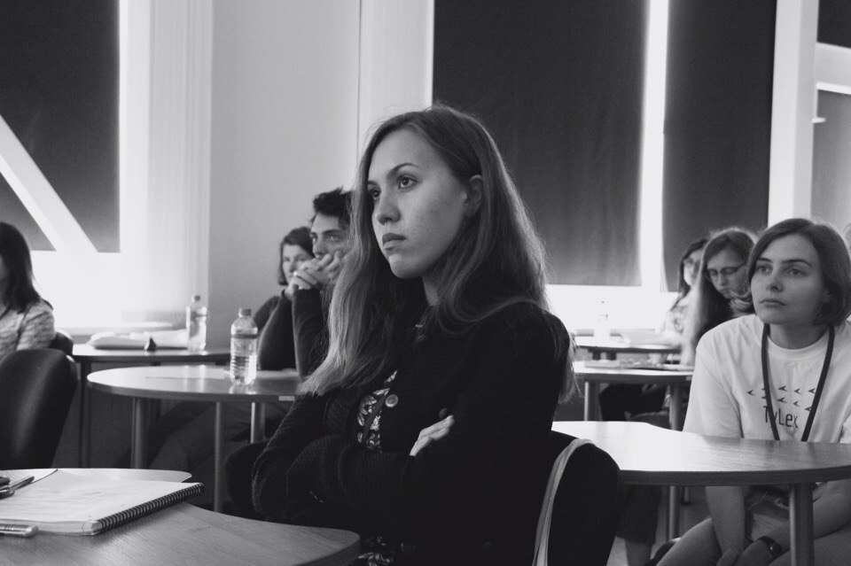

**Academic Researcher, specializing in Syntax and Typology**

Junior research fellow, Lab. for the Typological Study of Languages, ILS RAS

Research assistant, Linguistic Convergence Laboratory, HSE University

Visiting Lecturer, HSE University

+ 7-906-606-78-79

[natalielo009@gmail.com](mailto:natalielo009@gmail.com)

♦ Orcid: 0000-0003-0408-5964 ♦ ResearcherID: AAH-3582-2021 ♦ GitHub: natalielo00

Aramaic dialects

Chuvash

Russian

Relativization

Questions

Apposition

Education

**2020 BA Degree (with honor):** *Philology*, National Research University Higher School of Economics in Saint Petersburg, St. Petersburg School of Arts and Humanities, Saint-Petersburg

**2022 MA Degree (with honor):** *Linguistic Theory and Language Description*, National Research University Higher School of Economics, School of Linguistics, Moscow

**2021** Exchange student, *Theoretical Linguistics*, Fakultet for humaniora, samfunnsvitenskap og lærerutdanning, Universitetet i Tromsø – Norges arktiske universitet (UiT+ ex HiTø), Tromsø

Work experience

**2023 –** … Research assistant, Linguistic Convergence Laboratory, HSE University

**2022** – … Visiting Lecturer at the Faculty of Humanities, School of Linguistics, HSE University (Typology, Academic writing)

**2022 – …** Junior research fellow, Laboratory for typological studies, Institute for Linguistic Studies of Russian Academy of Science

**2019–2022** Lab assistant, Laboratory for typological studies, Institute for Linguistic Studies of Russian Academy of Science

**2021** Additional education teacher, English First

Teaching assistant (Morphology), HSE University, Nizhniy Novgorod

**2020** Teaching assistant (Morphology), HSE University, Nizhniy Novgorod

**2019–2020** Teaching assistant (Theoretical approaches to language), HSE University, Saint-Petersburg

**2018** Teaching assistant (Introduction to linguistics), HSE University, Saint-Petersburg

Publications

**Submitted** Apposition. In Marc L. Greenberg (ed.). Encyclopedia of Slavic Languages and Linguistics. Leiden: Brill. (submitted 15.02.2022)

Towards a typology of close appositional constructions. *STUF — Language Typology and Universals.* (submitted 01.03.2023)

**In press** Corpus study of causal čerez ‘through’ in Russian: diachrony and use in the modern language. *Slavia*.

**2023** Relative clauses in Maloe Karachkino Chuvash. *Ural-Altaic Studies*. 2023. Vol. 42. P. 70–90.

Case marking and definiteness in Slavic appositional constructions. *Slověne = Словѣне. International Journal of Slavic Studies*. 2022. Vol. 11. No. 1. P. 281–304.

Polar questions. Materials for the corpus grammar of Russian. Manuscript. Moscow, 2023. Available via link: https://clck.ru/am2vY (in Russian)

Question particles. Materials for the corpus grammar of Russian. Manuscript. Moscow, 2023. Available via link: https://clck.ru/am2vY (in Russian)

**2022** Nominal appositional constructions // Materials for the corpus grammar of Russian. Manuscript. Moscow, 2022. Available via link: https://clck.ru/am2vY (in Russian)

The syntactic status of arguments in the construction of predicative possession in NENA Urmi dialect. *Rhema*. 2022. No. 2. Pp. 67–85. (in Russian)

**2021** Copula agreement in Urmi dialect. In Mischenko D. F., Gerasimov D. V. (eds.). 18th Conference on Typology and Grammar for Young Scholars. Book of abstracts (Saint-Petersburg, 25–27 November 2021 г.). Saint-Petersburg: ILS RAS, 2021. P. 237–241.

Case concord in Slavic appositions In SCLC-2020/2021. The Slavic Cognitive Linguistics Conference (UiT The Arctic University of Norway, Tromsø, Norway, June 3–6, 2021). Book of Abstracts, 2021. P. 56–59.

**2020** Non-verbal predication in Urmi NENA. In Zabelina E. A., Logvinova N. N. (eds.). 17th Conference on Typology and Grammar for Young Scholars. Book of abstracts (Saint-Petersburg, 19–21.11.2020). Saint-Petersburg, 2020. P.77–80. (in Russian)

**2019** Adnominal clausal constructions with particles on ­agan/-egen and ­nə/-në in Maloe Karachkino Chuvash. In Zabelina E. A. (ed.). 16th Conference on Typology and Grammar for Young Scholars. Book of abstracts (Saint-Petersburg, 21–23.11.2019). Saint-Petersburg, 2019. P. 68–71. (in Russian)

Non-possessive functions of the 3rd person possessive marker in Maloe Karachkino Chuvash. *Acta Linguistica Petropolitana*. *Trudy instituta lingvisticheskix issledovaniy RAN*. Vol. 15, No, 2, 2019. P. 86–129. (in Russian)

Distribution of prepositions v and za in telic extent adverbials in Russian from 18th to 20th centuries. *Russkij jazyk v nauchnom osveshchenii (Russian Language and Linguistic Theory)*. Vol. 37, No. 1. 2019. P. 184–207. (in Russian)

**2017** Non-possessive functions of the 3rd person possessive marker in Maloe Karachkino Chuvash. In Mischenko D. F (ed.). 14th Conference on Typology and Grammar for Young Scholars. Book of abstracts (Saint-Petersburg, 23–25.11.2017). Saint-Petersburg, 2017. P. 65–69. (in Russian)

talks

**2023** Nominal causal expressions in Turkic. Talk presented at the Tu+8 Eighth Workshop on Turkic and Languages in Contact with Turkic. Harvard, Cambridge, Massachusetts, 4–5 March 2023.

**2021** Copula agreement hierarchy in Urmi NENA. Talk presented at the 18th Conference on Typology and Grammar for Young Scholars. ILS RAS, Saint-Petersburg, 25–27 November 2021.

With M. Kholodilova and S. Oskolskaya. Syntactically conditioned word-initial voicing in Poshkart Chuvash. Talk at “TheorLing 2021.Theoretical linguistics in the light of the interaction of qualitative and quantitative approaches”. University of Neuchâtel, 21–22 June, 2021.

Case agreement in Slavic appositional constructions. Talk given at Slavic Cognitive Linguistics Conference (SCLC-2020/2021), UiT The Arctic University of Norway. June 3-6, 2020.

**2019** Appositive oblique in Russian. Talk at “Constructional and Lexical Semantic Approaches to Russian — VI”, Saint Petersburg, Russia, 3-5 October 2019.

Typology of close appositional constructions with proper names. Talk at the 9th thematic conference “Typology of Morphosyntactic Parameters”. Moscow, Russia, 16-18 October 2019.

Noun-modifying clausal constructions with participial forms on – agan/-egen and -nə/-në in Maloye Karachkino dialect of Chuvash. Talk at the Conference on Typology and Grammar for Young Scholars. Saint Petersburg, Russia, 21-23 November 2019.

**2018** Case marking of proper names in appositive constructions in Russian.Talk at the 8th thematic conference “Typology of Morphosyntactic Parameters”. Moscow, Russia, 22-24.10.18.

On the evidence of phonetic integrity of appositive constructions with proper names in Russian. Talk at “PoleFon-2018: Field and Experimental Phonetics in Moscow”, Moscow, 19-20.10.18.

The Distribution of Russian telic-extent adverbials with prepositions ‘v’ and ‘za’ in 18-20th centuries. Poster presentation on 51st Annual Meeting of the Societas Linguistica Europaea. Tallinn, 29.08-01.09.18.

2023 – …

Other research work

**2021 –** … Ovsjannikova, Maria, Kirill Kozhanov, Natalia Logvinova, Alexey Lyavdansky, Alina Russkix, Sergey Say, Varvara Shuvalova, Elena Shvedova, and Elizaveta Zabelina. 2022–. Corpus of NENA varieties spoken in Russia. Available online at <https://nena-dict.ru/corpus>.

Say Sergey, Natalia Logvinova, Elizaveta Zabelina, and Natalia Zaika. 2022. NoCaCoDa: Nominal Causal Constructions Database. St. Petersburg: Institute for Linguistic Studies, RAS. Available online at: <https://nocacoda.info/>

**2021** Janda Laura, Tore Nesset, Anna Endressen. Russian Constructicon (https://site.uit.no/russian-constructicon/students/). Syntactic annotation. Available online at: https://constructicon.github.io/russian/about/

**2019** Sole creation and development of FLEx field corpus of Maloe Karachkino Chuvash

**2021** New Arameic (Urmia, Krasnodar region, Russia), head: S. Say

Chuvash (Maloe Karachkino, Chuvashia, Russia), head: M. Kholodilova

**2019** New Arameic (Urmia, Krasnodar region, Russia), head: S. Say

Chuvash (Maloe Karachkino, Chuvashia, Russia), head: M. Kholodilova

**2018** Chuvash (Maloe Karachkino, Chuvashia, Russia), head: M. Kholodilova

**2017** Chuvash (Maloe Karachkino, Chuvashia, Russia), head: M. Kholodilova

2023 – …

Grants

РФФИ 20-312-70009, 2020–2021 Gramatical properties of the Turkic languages of Volga region

Head: S. Oskolskaya

РФФИ 20-012-00312 А, 2020–2022 Documentation of North-East Neo-Aramaic dialects of Russia

Head: S. Say

РНФ №18-18-00472 Causal constructions in the languages of the world: semantics and typology

Head: V. Khrakovskij

2023 – …

Fellowships

**2021** University of Tromsø fellowship for working on Russian Constructicon (under the supervision of Laura Janda and Tore Nesset) (January 1, 2021 — June 30, 2020).

**2020** Best University Graduate in Saint-Petersburg-2020

**2019** DAAD Stipendium zur wissenschaftlichen Aus- und Fortbuildung in Deutschland (given in May 2019)

**2018** Saint-Petersburg Government Scholarship named after D. A. Granin (September 1, 2018 — June 30, 2019)

**2017** Personal scholarship provided by the Government of Saint-Petersburg in the fields of Physics, Mathematics, Chemistry, Russian language and Informational Technologies (September 1, 2017 — June 30, 2018)

**2016** Personal scholarship provided by the Government of Saint-Petersburg in the fields of Physics, Mathematics, Chemistry, Russian language and Informational Technologies (September 1, 2016 — June 30, 2017)

2023 – …

Summer Schools

2022 Fourth visiting seminar of the Society of Field Linguists, October 1–2, 2022 (village Ivankovo, Novgorod region).

2019 Fall School for Formal Syntax and Formal Semantics (3-FS), Moscow, September 1–7.

The St. Petersburg Institute of Linguistics, Cognition and Culture (NYI), July, 15–August, 2, Saint-Petersburg.

2018 Areal Linguistics and Languages of Russia, September 10–14, Moscow.

2017 International Summer School on Typology and Lexicon (TyLex), September 2–8, Moscow.

2023 – …

Editor Work

2020 Book of Abstracts for the XVII Conference in typology and grammar for young researchers. Saint Petersburg: Nestor-Istoria, 2020.

2023 – …

Languages

Russian native

English free (7,5 IELTS 2020)

German B2, on-Set 2018

French reading and writing, speaking on certain topics

Chuvash free reading of fiction

Python basic NLP and data science

R certain packages

2023 – …

Working with programs

ELAN, Praat, Field Works Languages explorer